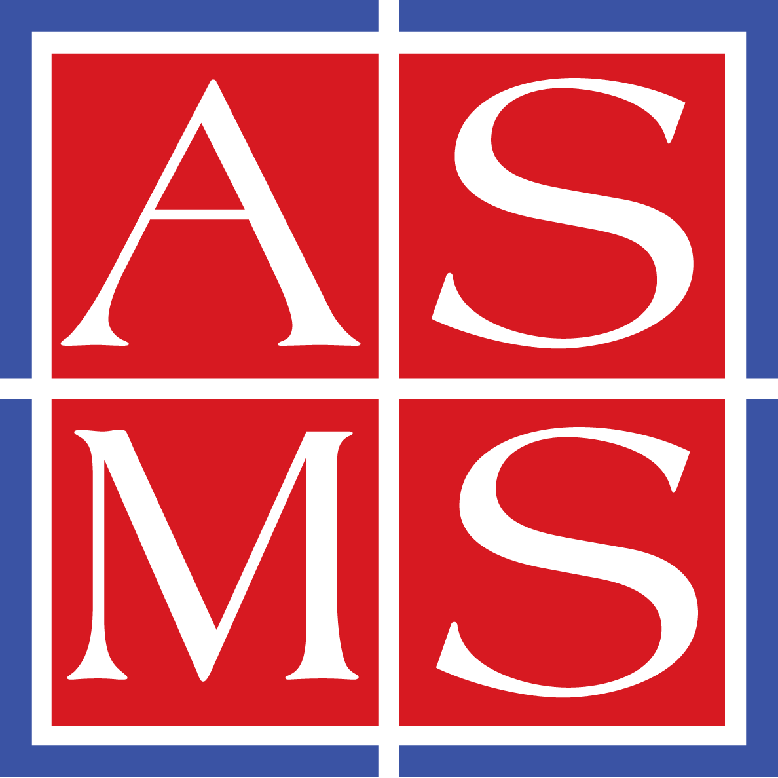 | American Society for Mass Spectrometry  2019 Galisteo Street, Building I-1, Santa Fe, NM 87505  Telephone: (505) 989-4517 | Fax: (505) 989-1073 | info@asms.org  SPECIAL EMERITUS RENEWAL FORM Renew online: www.asms.org

Special Emeritus member benefits include complimentary membership and annual conference registration. These special benefits are in addition to the regular member benefits listed below.

ASMS members receive:
- Access to the monthly Journal of the American Society for Mass Spectrometry (JASMS). This is online access to JASMS. The print edition of JASMS ended with the December issue 2019.
- Discounted registration for all small conferences and short courses
- Access to private areas of the web site (www.asms.org): the employment center, archives of the conference proceedings, archives of the John Wiley mass spectrometry journals, and collection of tutorial, award, and plenary lectures presented at the annual conference.

RENEW YOUR EMERITUS MEMBERSHIP ONLINE or complete this SPECIAL RENEWAL FORM

If you need assistance with your login credentials for ASMS.org in order to renew your emeritus membership online, please contact the ASMS office and info@asms.org and we will assist you.

Emeritus

First Name Last Name Affiliation. This is a required field in our database.
We prefer to use ‘Emeritus’ in this field

for our emeritus members.

Address

City State/Province Zip/Postal Code Country

Telephone Email, used only for ASMS communications to members. Be sure your address is accurate.

PLEASE SEE NEXT PAGE TO COMPLETE YOUR EMERITUS MEMBERSHIP RENEWAL
Demographic Data and Form Submission Details
ASMS EMERITUS MEMBERSHIP RENEWAL – Page 2

Demographic Data for Emeritus Member
As a society we hope to serve a diverse group of researchers and scholars from different backgrounds in a transparent manner. Personal information will remain confidential.
We request that emeritus members provide the demographic data below. Thank you.

I identify my ethnicity and/or race as (select all that apply):  Black or African Ancestry  Central Asian (e.g., Afghani, Armenian, Azerbaijani, Georgians, Kazakh, Kyrgyz, Mongolian, Tajik, Turkmen, Uzbek)  East Asian (e.g., Chinese, Japanese, Korean, Okinawan, Taiwanese, Tibetan)  Hispanic  Indigenous Peoples (e.g., Native American, Alaskan, Pacific Islander, etc.)  Latino/a/x  Middle Eastern/West Asian (e.g. Bahraini, Emerati, Iranian, Iraqi, Israeli, Jordanian, Kuwaiti, Lebanese, Omani, Palestinian, Qatari, Saudi Arabian, Syrian, Turkish, and Yemeni)  North African  Southeast Asian (e.g., Bruneian, Burmese, Cambodian, Filipino, Hmong, Indonesian, Laotian, Malaysian, Mien, Singaporean, Timorese, Thai, Vietnamese)  South Asian (e.g., Bangladeshi, Bhutanese, Indian, Maldivians, Nepali, Pakistani, Sri Lankan)  White  Do not wish to provide  Prefer to self-describe | I identify my gender as (select all that apply):  Woman  Man  Non-binary  Do not wish to provide  Prefer to self-describe  Job position or sector:  We have pre-selected the appropriate selection for emeritus members.  Retired or Emeritus

COMPLETED FORM SUBMISSION
Mail to: ASMS Dues, 2019 Galisteo Street, Building i-1, Santa Fe, NM 87505 (USA).
Email completed forms to info@asms.org.

