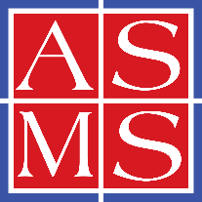 | American Society for Mass Spectrometry  2019 Galisteo Street, Building I-1, Santa Fe, NM 87505  (505) 989-4517 | Fax: (505) 989-1073 | info@asms.org | www.asms.org
President  Joseph A. Loo  University of California  Los Angeles, CA  Vice President for Programs  Carlito Lebrilla  University of California  Davis, CA  Vice President Arrangements  Roy Martin  Waters Corporation  Milford, MA  Secretary  Si Wu  University of Alabama  Tuscaloosa, AL  Treasurer  Heather Desaire  University of Kansas  Lawrence, KS  Member-at-Large Publications  Brian H. Clowers  Washington State University  Pullman, WA  Member-at-Large Membership  G. Asher Newsome  Smithsonian Institution  Suitland, MD  Member-at-Large Education  Elyssia Gallagher  Baylor University  Waco, TX  Past President  Julia Laskin  Purdue University  West Lafayette, IN  Archivist/Historian  P. Jane Gale  Executive Director  Jennifer Watson  Santa Fe, NM | April 20, 2026  Your Name  Your Affiliation  Your Street Address  Your City, State/Region, Postal Code  Your Country  Passport Number: Your passport number  Country of Issue: Country that issued your passport  Planned Arrival to the USA: Enter your arrival date, format as Month DD, YYYY  Planned Departure from the USA: Enter your departure date, format as Month DD, YYYY  Dear Your Name,  It is my great pleasure to invite you to attend the ASMS Fall Workshop on Characterization of Nucleic Acids and Their Modifications by LC-MS/MS, November 12-13, 2026, at the Boston Marriott Cambridge, Massachusetts, USA. The program begins Thursday morning, 8:00 am, November 12, 2026, and concludes Friday evening, 5:00 pm, November 13, 2026.  The ASMS Fall Workshop is a small-focused topic meeting with approximately 100 attendees. It involves scientists in academia, industry, and government, with presenters coming from all over the world. As such, it is a vital resource for U.S. scientists to share and collaborate with their international colleagues and directly serves the national interests of the United States by providing U.S. scientists with a rich and prestigious platform for scientific exchange. ASMS is a 501(c)3 non-profit corporation, with a membership of over 7,500 scientists involved in research and development.  We regret that we are not able to provide financial assistance.  We look forward to greeting you at Asilomar!  Best Regards,  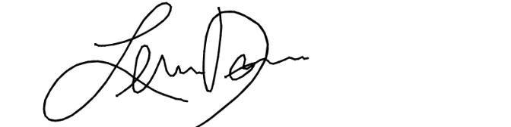  Lena Drake  Conference Manager  American Society for Mass Spectrometry (ASMS)  2019 Galisteo St, Bldg I-1  Santa Fe, NM 87505, USA  Tel. +1-505-989-4517

