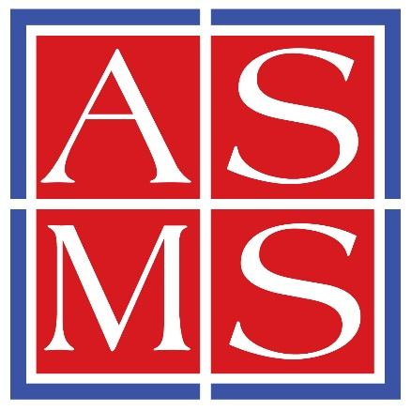

Replace with Your Course Title

Awarded to
Replace with Your Name

for successful completion of the above Short Course totaling 8 hours of instruction

Presented by

The American Society for Mass Spectrometry

May 31, 2025

Elyssia Gallagher

Baltimore, MD Member at Large for Education

