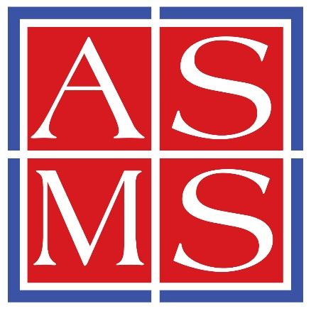

Replace with Your Course Title

Awarded to
Replace with Your Name

for successful completion of the above Short Course totaling 16 hours of instruction

Presented by

The American Society for Mass Spectrometry

May 31 – June 1, 2025

Elyssia Gallagher

Baltimore, MD Member at Large for Education

