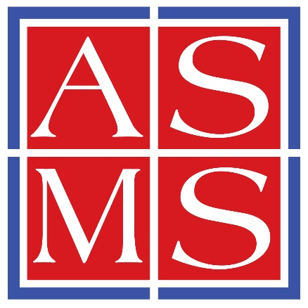

Title of Your 2-day Short Course
Awarded to
Your Name
for successful completion of the above Short Course totaling 16 hours of instruction

Presented by

The American Society for Mass Spectrometry

May 30 – 31, 2026

Lena Drake

San Diego, CA Conference Manager

